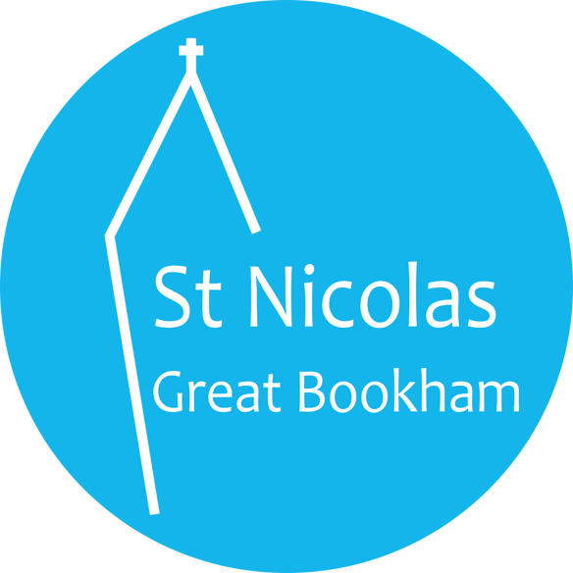
St Nicolas Church Room Booking Form
Registered Charity No: 1127867

I accept personal responsibility for ensuring the Rules & Conditions are complied with in connection with this booking
Signed by …………………………………….
Name…………………………………… Type of Event………………………………
Address………………………………… Organisation……………………………….
………………………………………….. Contact phone No…………………………
………………………………………….. Mobile no…………………………………..
Post code……………………………….. Charity no…………………………………..
E-mail………………………………………………………………………………………

- Date:………………………………………………………………………………

- Start time: Including setting up………………………………

- Finish time: Including clearing up…………………………….

- Numbers – Approx. number of people attending………………………………
Please note room capacity is 40 seated/50 standing

- Payment: £
£40 per session
Cheques should be made payable to St Nicolas PCC
BACS payment Sort Code 40-52-40 Account 00019044
(please email office@stnicolasbookham.org.uk if making an online payment, so we can notify the treasurer).
- Insurance provider………………………………

- Risk Assessment attached yes/no

